Guideline Glaucoma Detection:

*\*All of the experiment is conducted with Windows 10 64bit*

1. Software Installation:
2. Download and Install Python 3.8.5 at (<https://www.python.org/downloads/release/python-385/>)
3. Download and Install Anaconda 3.8 at (<https://www.anaconda.com/products/individual>)
4. Environment Set up:
5. Open Anaconda Navigator
6. Click Environments Tab

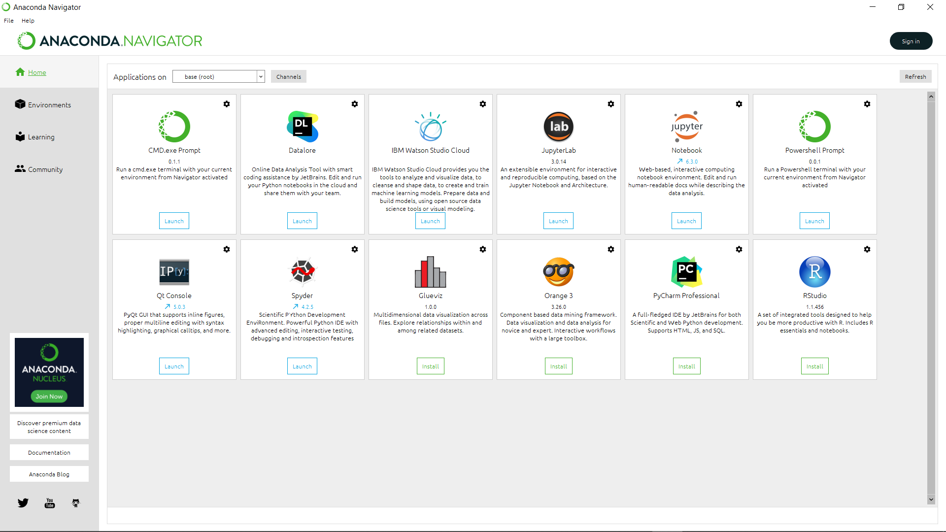

1. Click Create to create a new environment (for example set the environment’s name as “TensorFlow”)

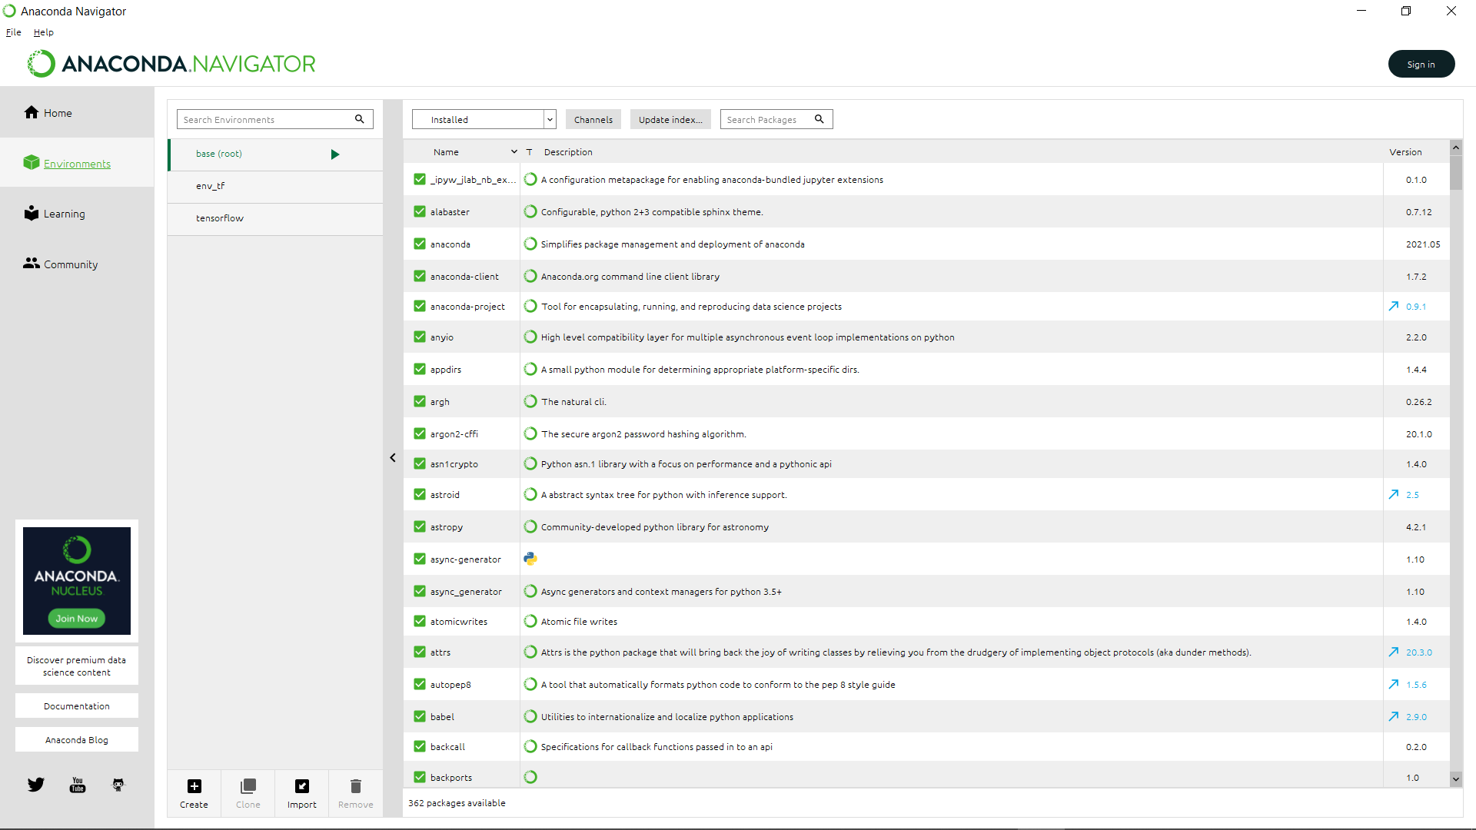

1. Add necessarily package by changing view tab to uninstalled and type the package name

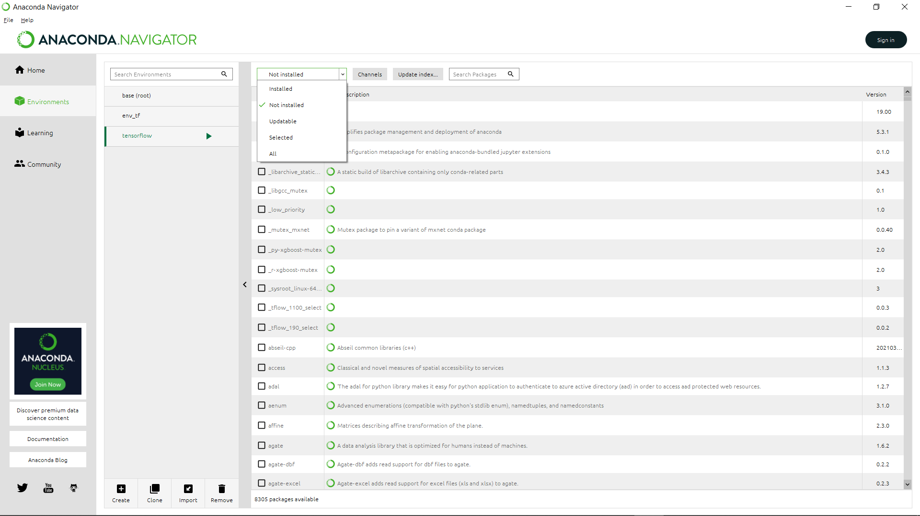

1. Make sure you have downloaded Jupyternotebook on your new environment.
2. Adding Dataset
3. Download Dataset from (<https://www.kaggle.com/sshikamaru/glaucoma-detection/download>)
4. Open Jupyternotebook and click new
5. Choose Python 3 Notebook

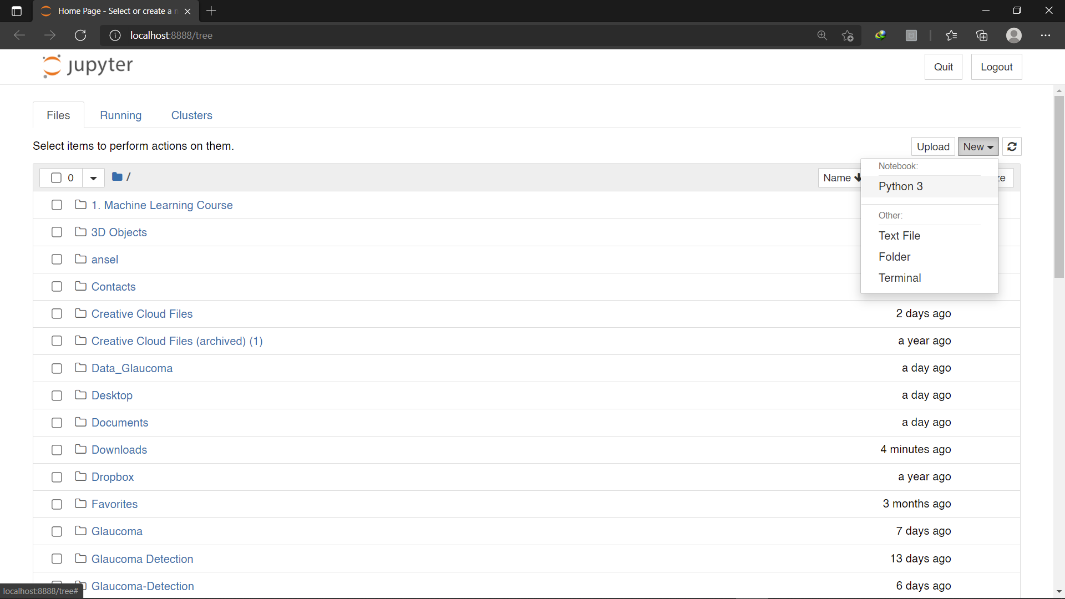

1. Type “pwd” and run the code; it will show the base path (location that we can put our dataset)

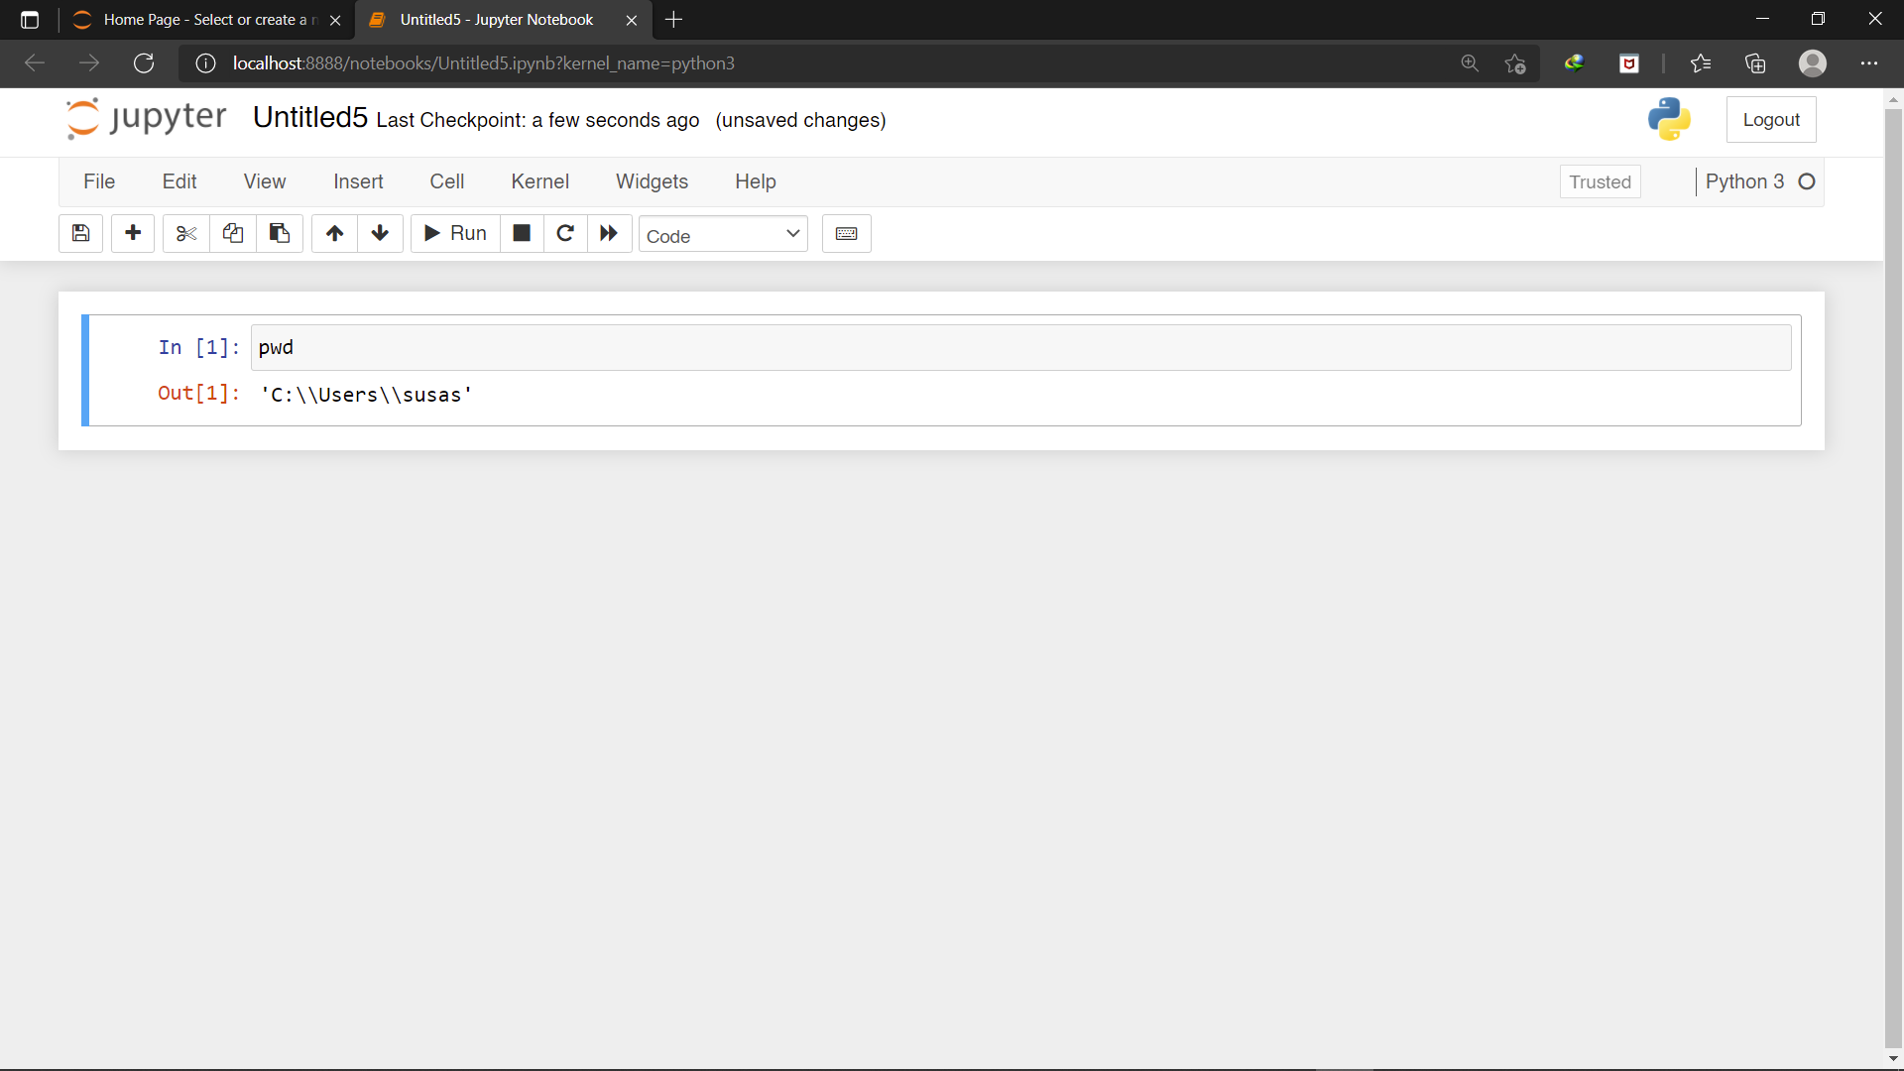

1. Copy Dataset to base path

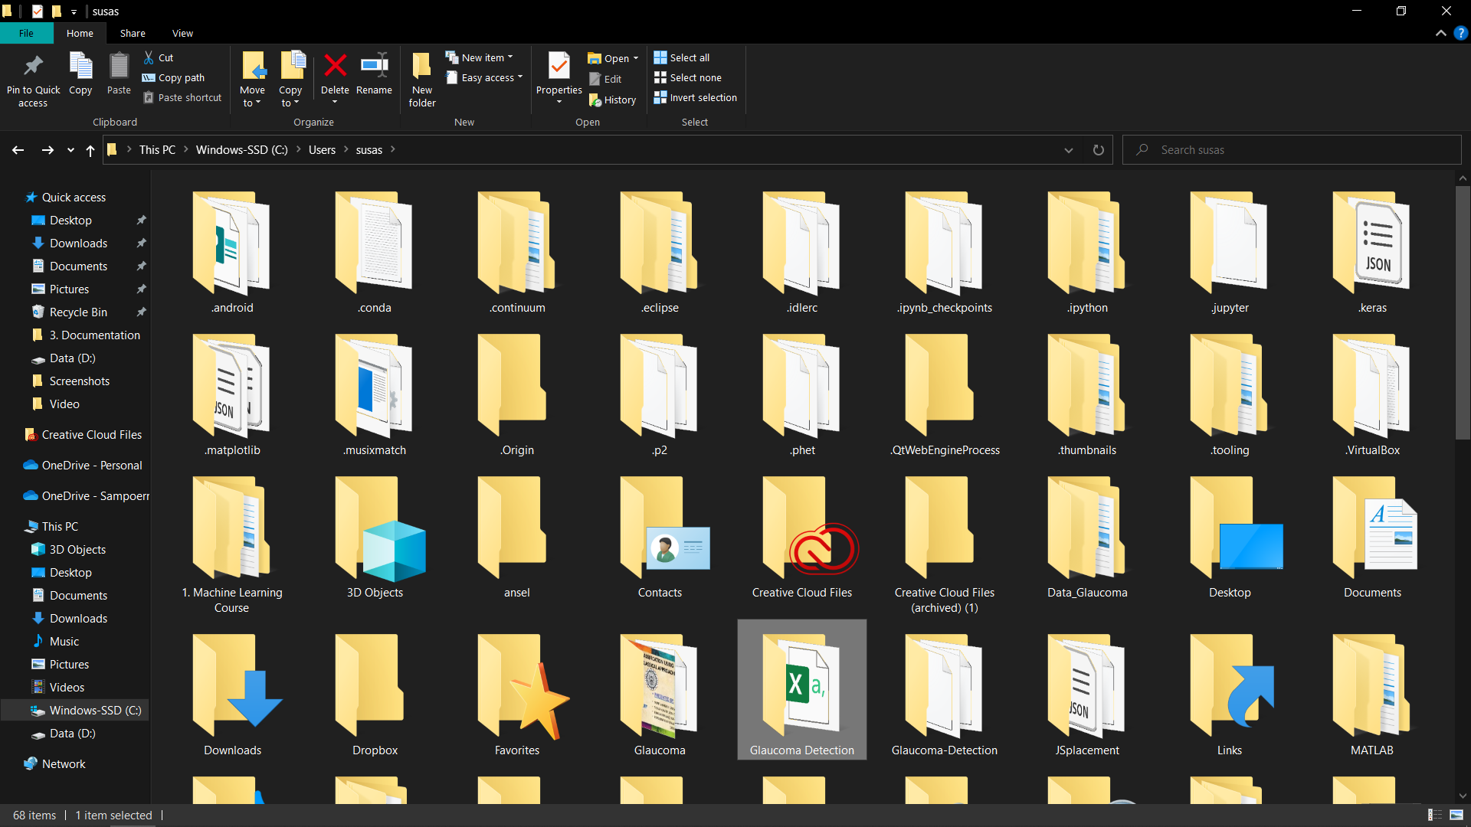

1. Running Code
2. Open code source from (<https://www.kaggle.com/sshikamaru/detecting-glaucoma-with-cnn-resnet-50>)
3. Clone all code; make sure to change path directory
4. Run code by press “Shift+Enter”